**Part 1: Launch AWS instances**

**Youtube:** <https://www.youtube.com/watch?v=UeDSotLuWr0>

**Step 1:**

Login to aws console

**Step 2:**

Choose ubuntu machines

**Step 3:**

Make open security

**Step 4:**

Download the private key file and store it at a safe place as this is the only chance you would be able to download it. Amazon doesn’t store it anywhere.

<https://docs.aws.amazon.com/AWSEC2/latest/UserGuide/ec2-key-pairs.html#retrieving-the-public-key-windows>

**Step 5:**

Launch 2 nodes and modify the names as datanode and namenode

**Step 6:**

Go to the aws console and make a note of public DNS for each node

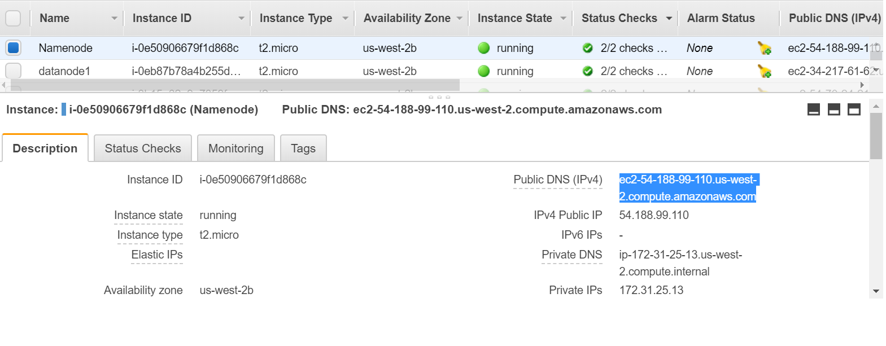

For example

Namenode: ec2-54-188-99-999.us-west-2.compute.amazonaws.com

Datanode: ec2-34-217-61-926.us-west-2.compute.amazonaws.com

**Part 2: Connect to AWS instances through Putty**

**Youtube:** <https://www.youtube.com/watch?v=ic7Cl-kwpRA>

<https://www.youtube.com/watch?v=171nS9OxLzE>

**Step 7:**

Generate private key using Puttygen tool which can be understood by Putty

<https://docs.aws.amazon.com/AWSEC2/latest/UserGuide/putty.html>

**Step 8:**

Open putty and start a connection with each node:

Use generated new ppk file in SSH->auth

Ip address is public DNS or public ip address of instance

**Part 3: Install Java**

**Step 9: All nodes**

Update repository

*sudo apt-get update*

**Step 10: All nodes**

Install Java

*sudo apt-get -y install openjdk-8-jdk-headless*

**Part 4: Download Hadoop**

**Step 11: All nodes**

*sudo wget http://archive.apache.org/dist/hadoop/common/hadoop-2.7.3/hadoop-2.7.3.tar.gz*

**Step 12: All nodes**

Extract files

*tar xvzf hadoop-2.7.3.tar.gz*

mv *hadoop-2.7.3 hadoop*

**Part 5: Modify .bashrc file**

**Step 13: All nodes**

Add following variables in *~/.bashrc* file

*#====== HADOOP VAR =======#*

*export JAVA_HOME=/usr/lib/jvm/java-8-openjdk-amd64*

*export HADOOP_INSTALL=/home/ubuntu/hadoop*

*export PATH=$PATH:$HADOOP_INSTALL/bin*

*export PATH=$PATH:$HADOOP_INSTALL/sbin*

*export HADOOP_MAPRED_HOME=$HADOOP_INSTALL*

*export HADOOP_COMMON_HOME=$HADOOP_INSTALL*

*export HADOOP_HDFS_HOME=$HADOOP_INSTALL*

*export YARN_HOME=$HADOOP_INSTALL*

*export HADOOP_COMMON_LIB_NATIVE_DIR=$HADOOP_INSTALL/lib/native*

*export HADOOP_OPTS="-Djava.library.path=$HADOOP_INSTALL/lib/native"*

**Step 14: All nodes**

Apply these changes

*source ~/.bashrc*

**Part 6: Create HDFS storage dir**

**Step 15: All nodes**

*sudo mkdir -p /usr/local/hadoop/hdfs/data  
sudo chown -R ubuntu:ubuntu /usr/local/hadoop/hdfs/data*

**Part 7: Modify configuration files**

**Step 16: All nodes**

**Go to the configuration directory**

*cd* *~/hadoop/etc/hadoop*

**Step 17: All nodes**

Set JAVA_HOME in hadoop-env.sh file

JAVA_HOME=/usr/lib/jvm/java-8-openjdk-amd64

**Step 18: All nodes**

Modify core-site.xml

*<configuration>  
 <property>  
 <name>fs.defaultFS</name>  
 <value><DNS of namenode>:9000</value>  
 </property>  
</configuration>*

**Step 19: Namenode**

Modify hdfs-site.xml

*<configuration>  
 <property>  
 <name>dfs.replication</name>  
 <value>3</value>  
 </property>  
 <property>  
 <name>dfs.namenode.name.dir</name>  
 <value>file:///usr/local/hadoop/hdfs/data</value>  
 </property>  
</configuration>*

**Step 20: datanode**

Modify hdfs-site.xml

*<configuration>*

*<property>  
 <name>dfs.replication</name>  
 <value>3</value>  
 </property>  
 <property>  
 <name>dfs.datanode.data.dir</name>  
 <value>file:///usr/local/hadoop/hdfs/data</value>  
 </property>*

*</configuration>*

**Step 21: Namenode**

Prepare mapred-site.xml

*cp mapred-site.xml.template mapred-site.xml*

Modify mapred-site.xml

<configuration>  
 <property>  
 <name>mapreduce.framework.name</name>  
 <value>yarn</value>  
 </property>  
</configuration>

**Note:** No need of mentioning job tracker address as its no longer used in MR2

<https://www.cloudera.com/documentation/enterprise/5-4-x/topics/cdh_ig_mapreduce_to_yarn_migrate.html>

**Step 22: Namenode**

yarn-site.xml

<configuration>  
 <!-- Site specific YARN configuration properties -->  
 <property>  
 <name>yarn.nodemanager.aux-services</name>  
 <value>mapreduce_shuffle</value>  
 </property>  
 <property>  
 <name>yarn.nodemanager.aux-services.mapreduce.shuffle.class</name>  
 <value>org.apache.hadoop.mapred.ShuffleHandler</value>  
 </property>  
 <property>  
 <name>yarn.resourcemanager.hostname</name>  
 <value><DNS of namenode></value>  
 </property>  
</configuration>

**Part 8: create multiple instances of datanode**

Create an Image of datanode

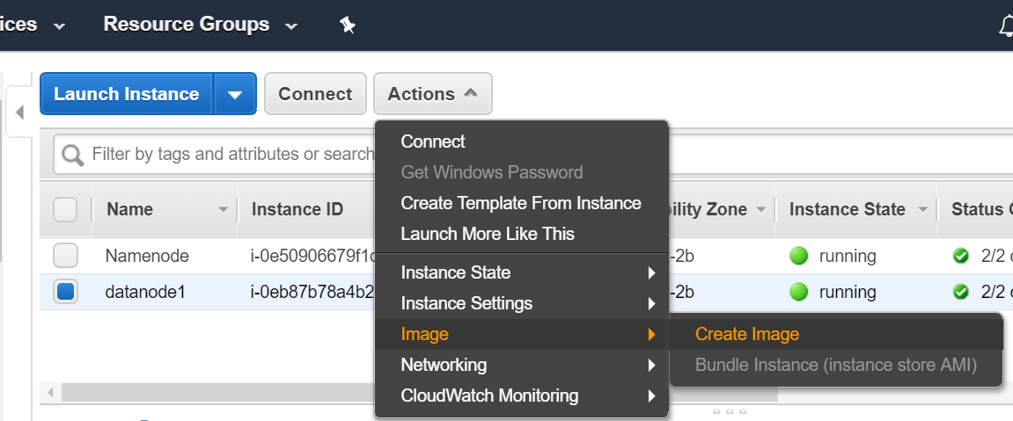

Launch multiple instances of this image from AMIs

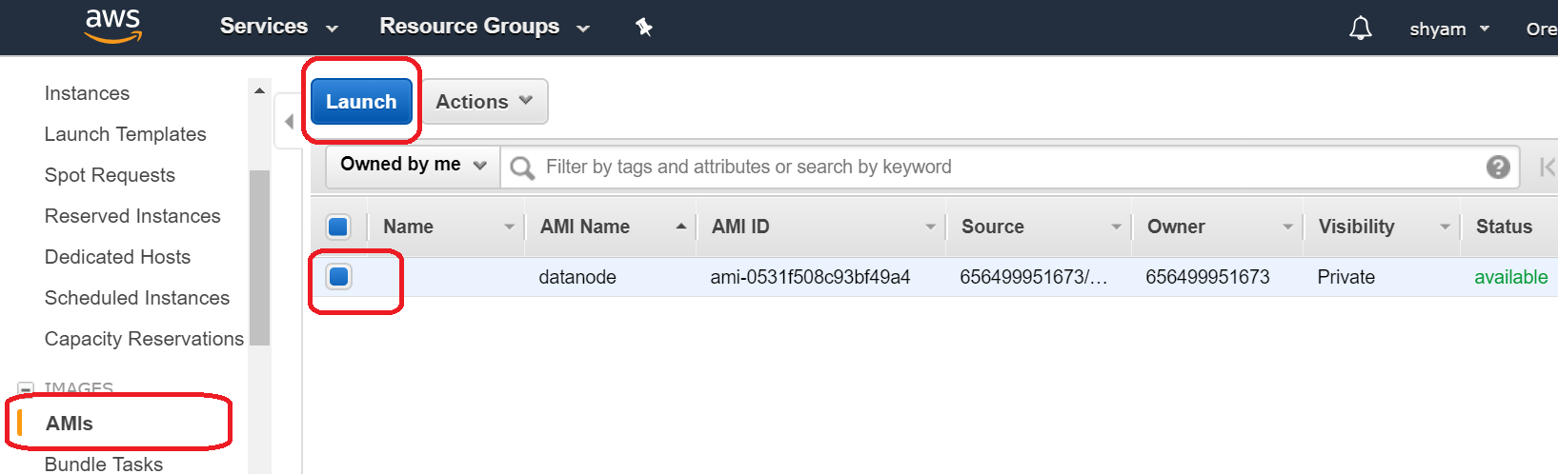

**Part 9: Configure SSH**

**Step 23: namenode**

*ssh-keygen*

**Step 24: namenode**

Copy the content of file */home/ubuntu/.ssh/id_rsa.pub* on clipboard

**Step 25: all nodes (datanodes + namenode)**

Paste that content in file *~/.ssh/authorized_keys*

**Step 26: namenode**

Configure node details in *~/.ssh/config* file.

*Host namenode  
 HostName <DNS of namenode>  
 User ubuntu  
 IdentityFile ~/.ssh/id_rsa  
  
Host datanode1  
 HostName <DNS of datanode1>  
 User ubuntu  
 IdentityFile ~/.ssh/id_rsa  
  
Host datanode2  
 HostName <DNS of datanode2>  
 User ubuntu  
 IdentityFile ~/.ssh/id_rsa  
  
Host datanode3  
 HostName <DNS of datanode3>  
 User ubuntu  
 IdentityFile ~/.ssh/id_rsa*

**Step 27: namenode**

check SSH connectivity

ssh namenode

ssh datanode1

ssh datanode2

ssh datanode3

**Part 10: set up masters and slaves**

**Step 28: Namenode**

Modify files as following:

1. masters

<DNS of namenode>

1. slaves

<DNS of datanode1>

<DNS of datanode2>

<DNS of datanode3>

**Part 11: Format namenode**

**Step 29: Namenode**

*hdfs namenode -format*

**Part 12: Start services**

**Step 30: Namenode**

Start HDFS service

*start-dfs.sh*

**Step 31: Namenode**

Start YARN service

start-yarn.sh

=====================================================================

**Notes**

**References:**

<https://www.novixys.com/blog/setup-apache-hadoop-cluster-aws-ec2/>

<https://letsdobigdata.wordpress.com/2014/01/13/setting-up-hadoop-multi-node-cluster-on-amazon-ec2-part-1/>

**Check public IPv4 on console:**

curl v4.ident.me

**Block location for a file in HDFS**

hdfs fsck /myfile.txt -files -blocks -locations

**Minimal Replicated Block:**

<https://issues.apache.org/jira/browse/HDFS-8720>

**Install Spark:**

<https://data-flair.training/blogs/install-apache-spark-multi-node-cluster/>